Software Requirements Specification
for
Student Result Management System (SRMS)
Version 1.0
Prepared by Himanshu Pandey, Drishay Chauhan, Durga Madheshiya
Date: 9 November 2025

Table of Contents
1. Introduction
1.1 Purpose
1.2 Document Conventions
1.3 Intended Audience and Reading Suggestions
1.4 Product Scope
1.5 References
2. Overall Description
2.1 Product Perspective
2.2 Product Functions
2.3 User Classes and Characteristics
2.4 Operating Environment
2.5 Design and Implementation Constraints
2.6 User Documentation
2.7 Assumptions and Dependencies
3. External Interface Requirements
3.1 User Interfaces
3.2 Hardware Interfaces
3.3 Software Interfaces
3.4 Communications Interfaces
4. System Features
4.1 User Authentication
4.1.1 Description and Priority
4.1.2 Stimulus/Response Sequences
4.1.3 Functional Requirements
4.2 Manage Students
4.2.1 Description and Priority
4.2.2 Stimulus/Response Sequences
4.2.3 Functional Requirements
4.3 Manage Courses and Marks
4.3.1 Description and Priority
4.3.2 Stimulus/Response Sequences
4.3.3 Functional Requirements
4.4 Generate and View Results
4.4.1 Description and Priority
4.4.2 Stimulus/Response Sequences
4.4.3 Functional Requirements
5. Other Nonfunctional Requirements
5.1 Performance Requirements
5.2 Safety Requirements
5.3 Security Requirements
5.4 Software Quality Attributes
5.5 Business Rules
6. Other Requirements
6.1 Future Enhancements
6.2 Legal and Regulatory Requirements
6.3 Data Retention and Backup
Appendix A – Glossary
Appendix B – Analysis Models
B.1 Use Case Diagram
B.2 Data Flow Diagrams (Level 0–2)
B.3 Entity Relationship Diagram
B.4 Class and Object Diagrams
B.5 Sequence and Activity Diagrams
B.6 Component and Deployment Diagrams
Appendix C – To Be Determined (TBD) List

Revision History
Version | Date | Description | Author | Approved By
1.0 | Nov 2025 | Initial Draft | [Your Name] | Project Supervisor

Approval Table
Role | Name | Signature | Date
Project Guide
Developer
QA Reviewer

1. Introduction
1.1 Purpose
The purpose of the Student Result Management System (SRMS) is to automate and streamline the process of recording, calculating, and publishing academic results for students.
The system minimizes human error, reduces processing time, and ensures secure access to student data.
This SRS defines the complete set of functional and non-functional requirements for the SRMS, serving as a reference for developers, testers, and academic administrators.

1.2 Document Conventions
- Requirements are labelled as FR-x (Functional Requirement) and NFR-x (Non-Functional Requirement).
- Figures and diagrams are referenced as Figure X.Y.
- Each section follows IEEE 830–1998 numbering format.

1.3 Intended Audience and Reading Suggestions
- Developers: Focus on Sections 3 and 4 for technical requirements.
- Testers: Review functional and performance requirements.
- Administrators: Refer to Section 2 for operational overview.
- Students/Teachers: Read Sections 4.3 and 4.4 for usage behaviour.

1.4 Product Scope
SRMS provides a web-based platform for managing academic data.
It allows administrators to manage student profiles and results, teachers to enter and update marks, and students to securely view their results.
It enhances accuracy, accessibility, and efficiency in the examination process.

1.5 References
- IEEE Std 830–1998: IEEE Recommended Practice for Software Requirements Specifications.
- Karl Wiegers (1999): IEEE SRS Template.
- Microsoft SQL Server Documentation.
- Project Design Documents (DFD, ERD, UML Diagrams).

2. Overall Description
2.1 Product Perspective
The SRMS is a stand-alone, client-server web application.
It operates within the institution’s network, communicating between the web interface, application layer, and SQL database.
Figure 2.1: Level 0 Data Flow Diagram
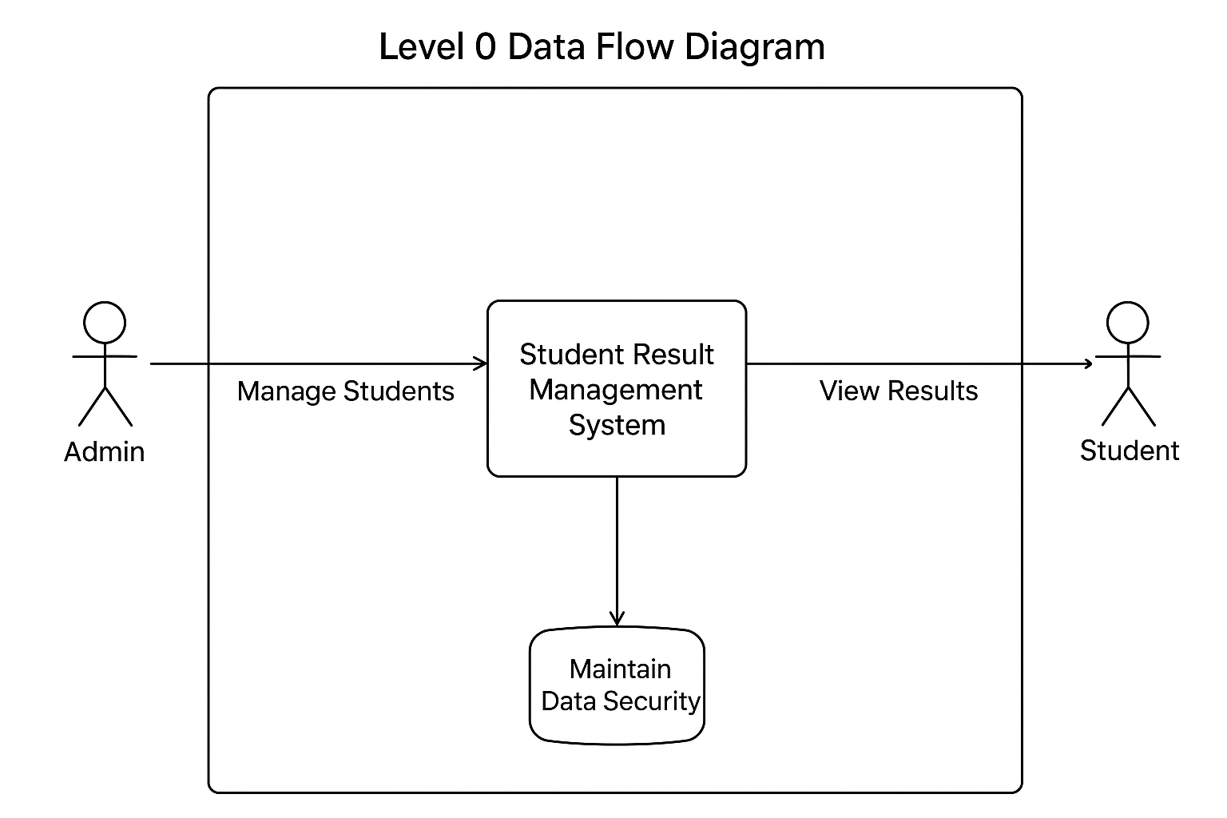

2.2 Product Functions
The key functions of SRMS include:
- User authentication and role management.
- Student and subject data entry and maintenance.
- Marks calculation and result compilation.
- Report generation and result export in XML format.
- Role-based result viewing.
Figure 2.2: Level 1 DFD
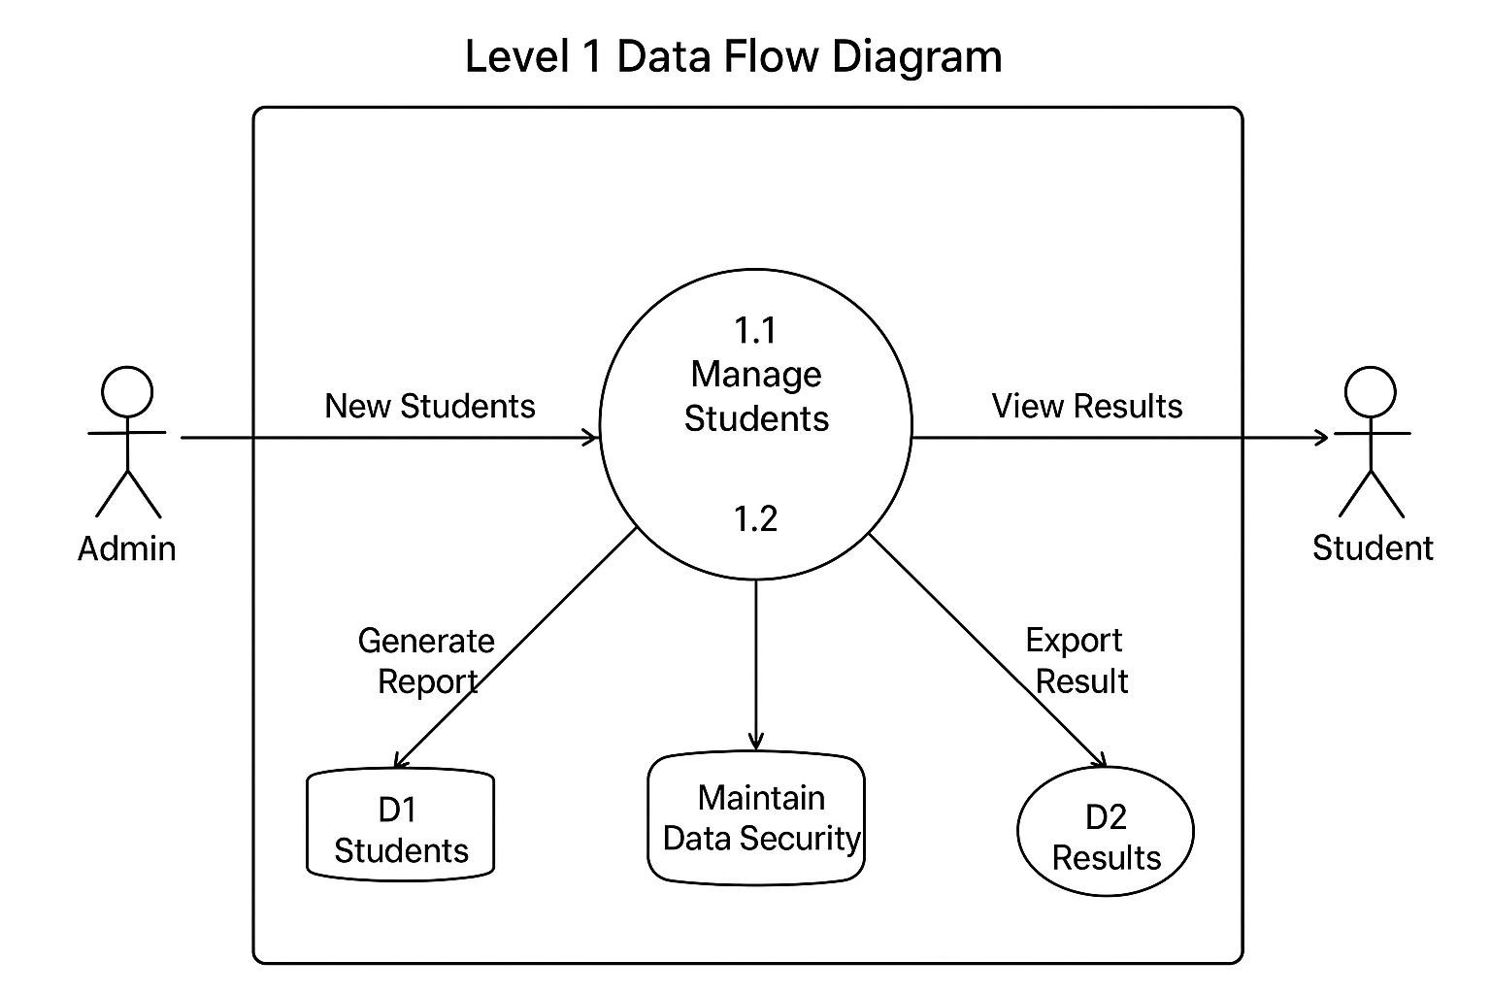

2.3 User Classes and Characteristics
User Role | Description | Access Level
Administrator | Manages system users, reports, and settings. | Full Access
Teacher | Inputs and updates marks for students. | Restricted
Data Entry Operator | Manages student and subject data. | Limited
Student | Views results and personal details. | View-only

2.4 Operating Environment
- OS: Windows 7/10/11
- Database: SQL Server 2008+
- Web Browser: Chrome, Edge, Firefox
- Development Framework: ASP.NET (C#)
- Server Type: IIS Web Server

2.5 Design and Implementation Constraints
- Must comply with institutional IT security policies.
- Should be implemented using Microsoft Visual Studio.
- Database normalization standards must be maintained.
- Limited to Windows-based environments.

2.6 User Documentation
- User Manuals for Admin, Teacher, and Student roles.
- Quick-start Guide for installation and setup.
- Online Help integrated into the interface.

2.7 Assumptions and Dependencies
- Users have valid login credentials.
- Stable network and server uptime are maintained.
- System depends on institutional database infrastructure.
- Browser compatibility assumed for latest versions.

3. External Interface Requirements
3.1 User Interfaces
The system will have:
- Login screen with username, password, and role selection.
- Admin dashboard for managing users and reports.
- Teacher interface for mark entry.
- Student portal for viewing results.

3.2 Hardware Interfaces
- Client machines with ≥ 1 GB RAM and 2 GHz processor.
- Server with ≥ 4 GB RAM and 100 GB storage.

3.3 Software Interfaces
- Database: Microsoft SQL Server 2008 or higher.
- Application Framework: ASP.NET with C#.
- Browser-based client interface.
- XML integration for data export/import.

3.4 Communications Interfaces
- HTTP/HTTPS for client-server communication.
- Internal LAN or institutional intranet connectivity.

4. System Features
4.1 User Authentication
4.1.1 Description and Priority
Ensures that only authorized users can access the system.
Priority: High
4.1.2 Stimulus/Response Sequences
- User enters credentials.
- System validates and grants access based on role.
4.1.3 Functional Requirements
- FR-01: System shall validate username and password.
- FR-02: System shall restrict access by role.
- FR-03: System shall log failed login attempts.

4.2 Manage Students
4.2.1 Description and Priority
Allows authorized users to create, update, and delete student profiles.
Priority: High
4.2.2 Stimulus/Response Sequences
- Admin selects “Manage Students.”
- User performs CRUD operations.
4.2.3 Functional Requirements
- FR-04: System shall allow addition and modification of student records.
- FR-05: System shall ensure unique enrolment numbers.
Figure 4.1: Use Case Diagram
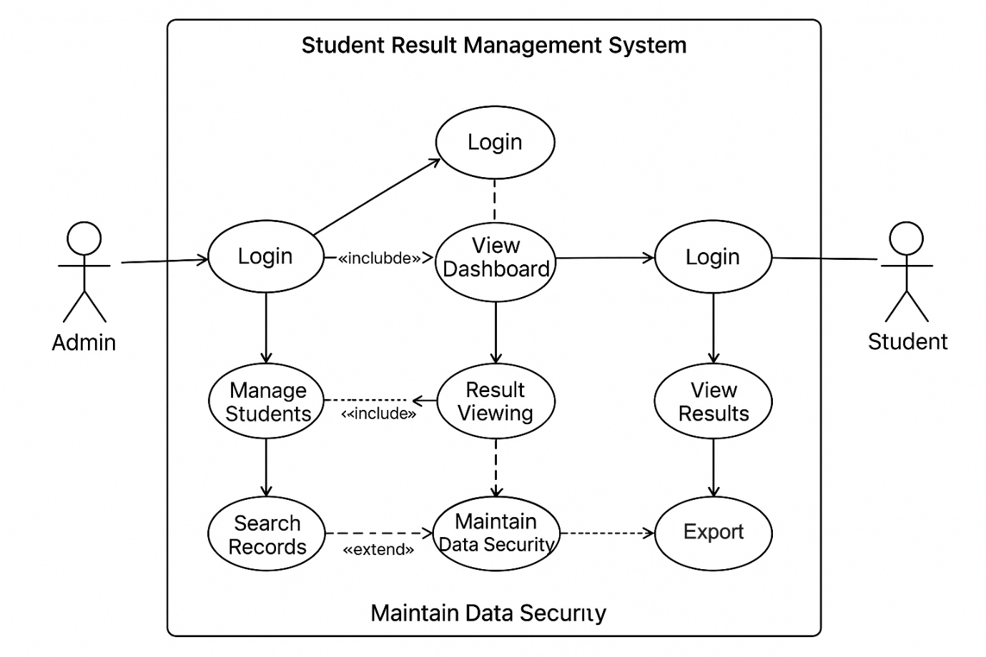

4.3 Manage Courses and Marks
4.3.1 Description and Priority
Teachers enter marks for students in specific subjects.
Priority: High
4.3.2 Stimulus/Response Sequences
- Teacher logs in and selects a course.
- Inputs student marks and submits.
4.3.3 Functional Requirements
- FR-06: System shall allow entry of marks.
- FR-07: System shall calculate total and grade automatically.
Figure 4.2: Activity Diagram
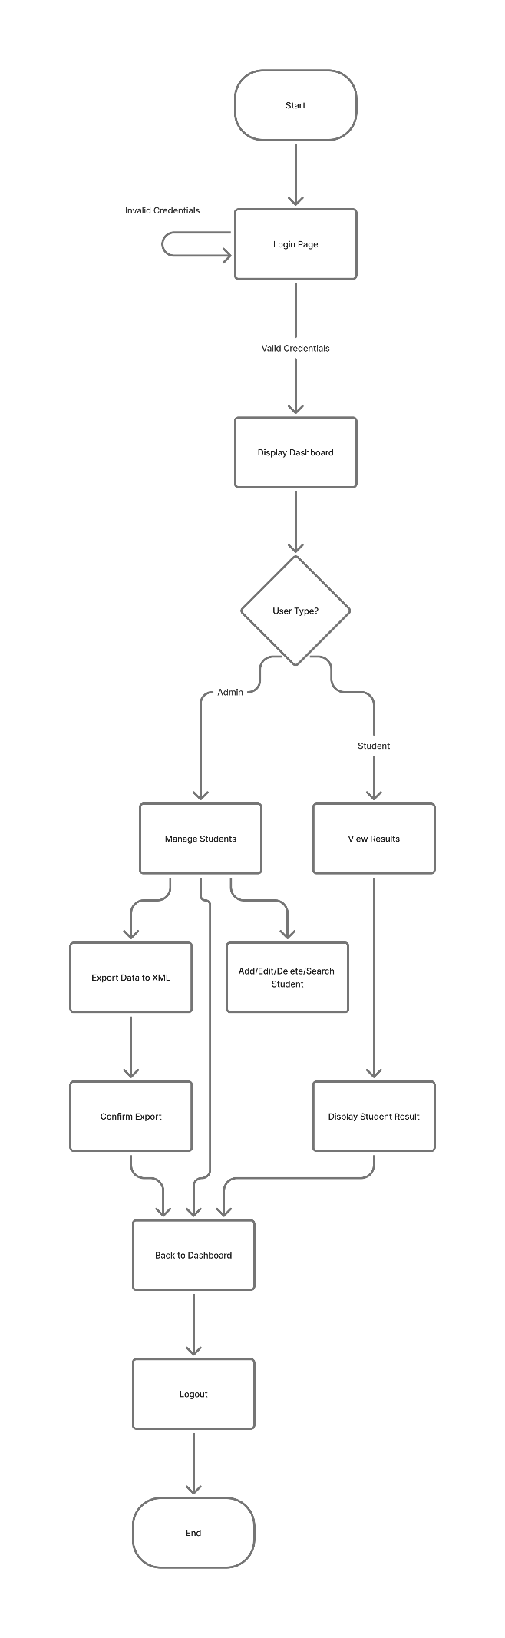

4.4 Generate and View Results
4.4.1 Description and Priority
Allows administrators to generate reports and students to view results.
Priority: High
4.4.2 Stimulus/Response Sequences
- Admin selects “Generate Results.”
- System compiles data and publishes report.
4.4.3 Functional Requirements
- FR-08: System shall generate result reports in tabular and printable formats.
- FR-09: System shall allow XML export of reports.
Figure 4.3: Sequence Diagram
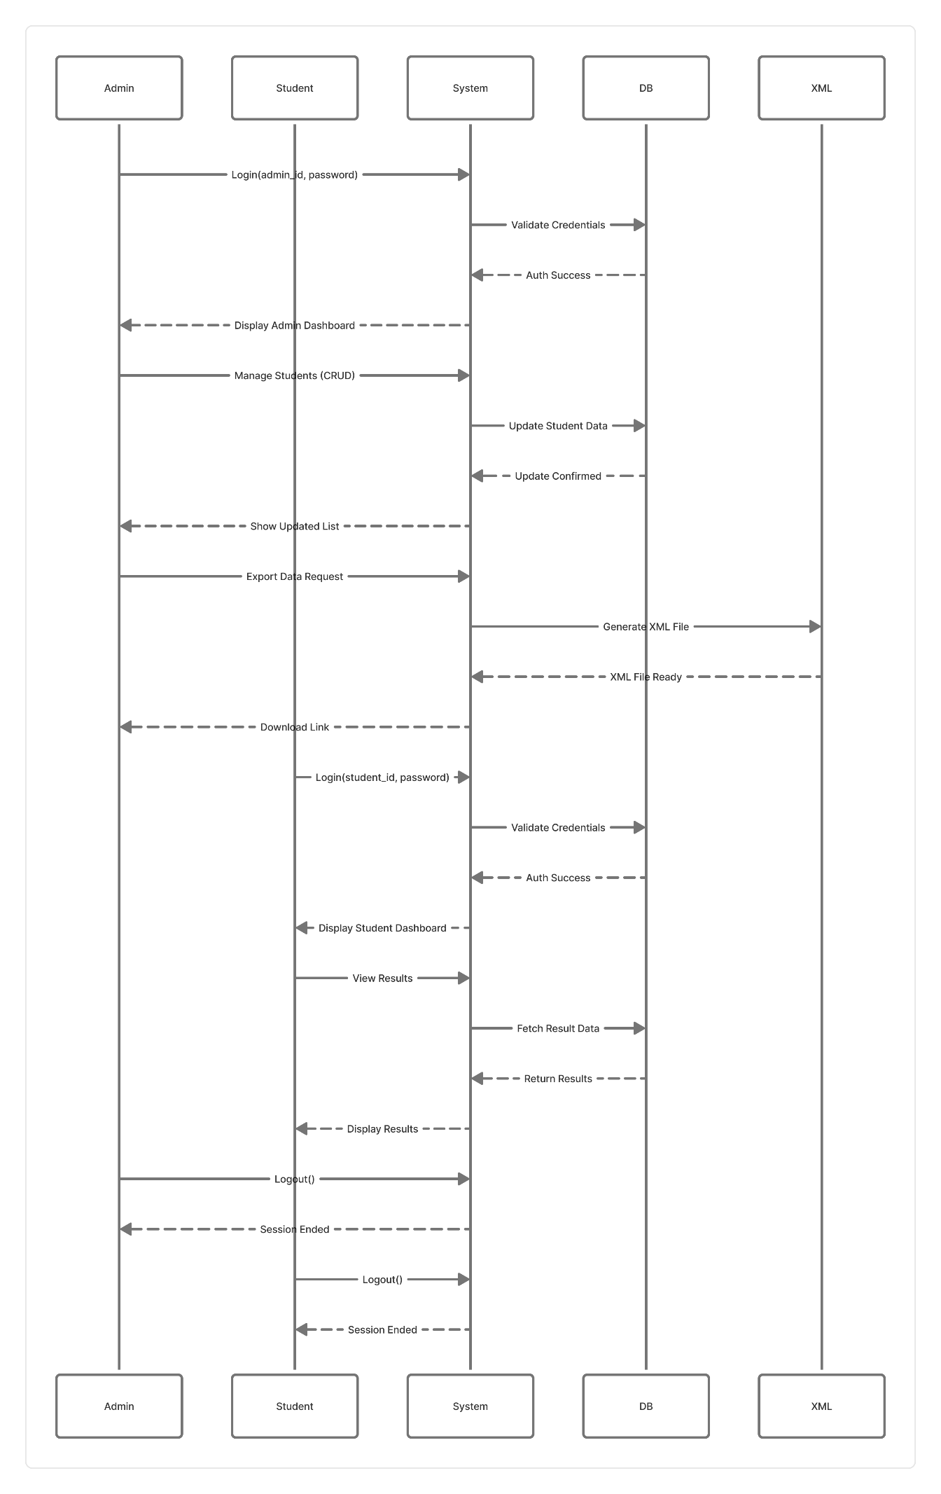
5. Other Nonfunctional Requirements
5.1 Performance Requirements
- The system shall respond to user actions within 3 seconds.
- Report generation shall complete within 5 seconds for up to 1000 records.

5.2 Safety Requirements
- Database backups will be performed automatically every 24 hours.
- Only administrators can perform data restoration.

5.3 Security Requirements
- Passwords stored in encrypted format.
- Role-based access enforced.
- User sessions timeout after 10 minutes of inactivity.

5.4 Software Quality Attributes
Attribute | Description
Reliability | 99% uptime under normal load.
Maintainability | Modular architecture for easy updates.
Scalability | Supports additional departments with minimal changes.
Usability | Simple and intuitive web interface.

5.5 Business Rules
- Marks cannot exceed maximum subject score.
- Students must have unique enrollment IDs.
- Only Admin can delete records permanently.

6. Other Requirements
6.1 Future Enhancements
- Integration of student attendance tracking.
- Mobile application for result viewing.
- API for external data access.

6.2 Legal and Regulatory Requirements
- Must comply with institutional data privacy and IT policy.
- Must adhere to academic integrity and grading guidelines.

6.3 Data Retention and Backup
- Records retained for a minimum of 5 years.
- Weekly full backup and daily incremental backup procedures.

Appendix A – Glossary
Term | Definition
SRS | Software Requirements Specification
SRMS | Student Result Management System
ERD | Entity Relationship Diagram
DFD | Data Flow Diagram
CRUD | Create, Read, Update, Delete
DBA | Database Administrator

Appendix B – Analysis Models
Figure B.1: Use Case Diagram
Figure B.2: Level 0 and level 1 DFDs
Figure B.3: ER Diagram
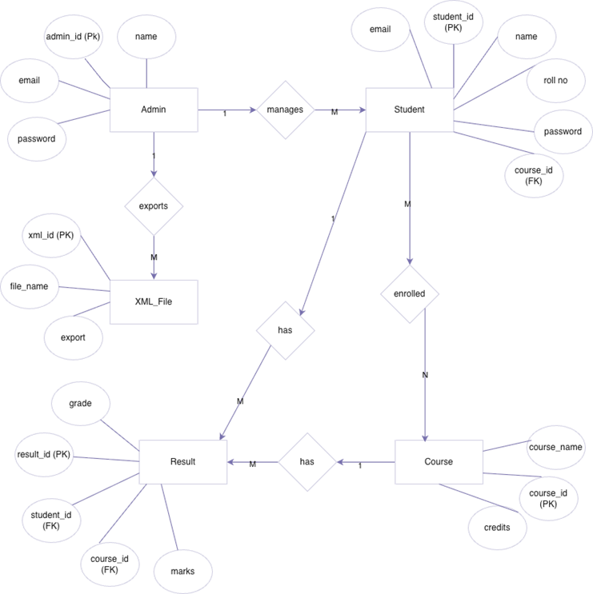
Figure B.4: Class and Object Diagrams
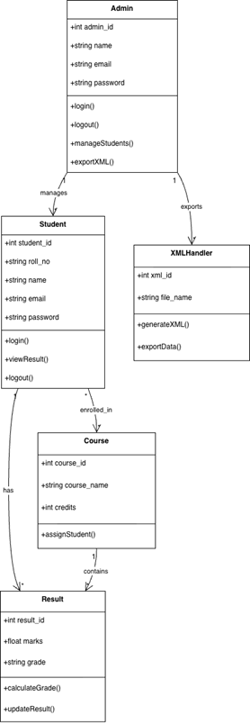
Figure B.5.1: Sequence Diagram
Figure B.5.2: Activity Diagram
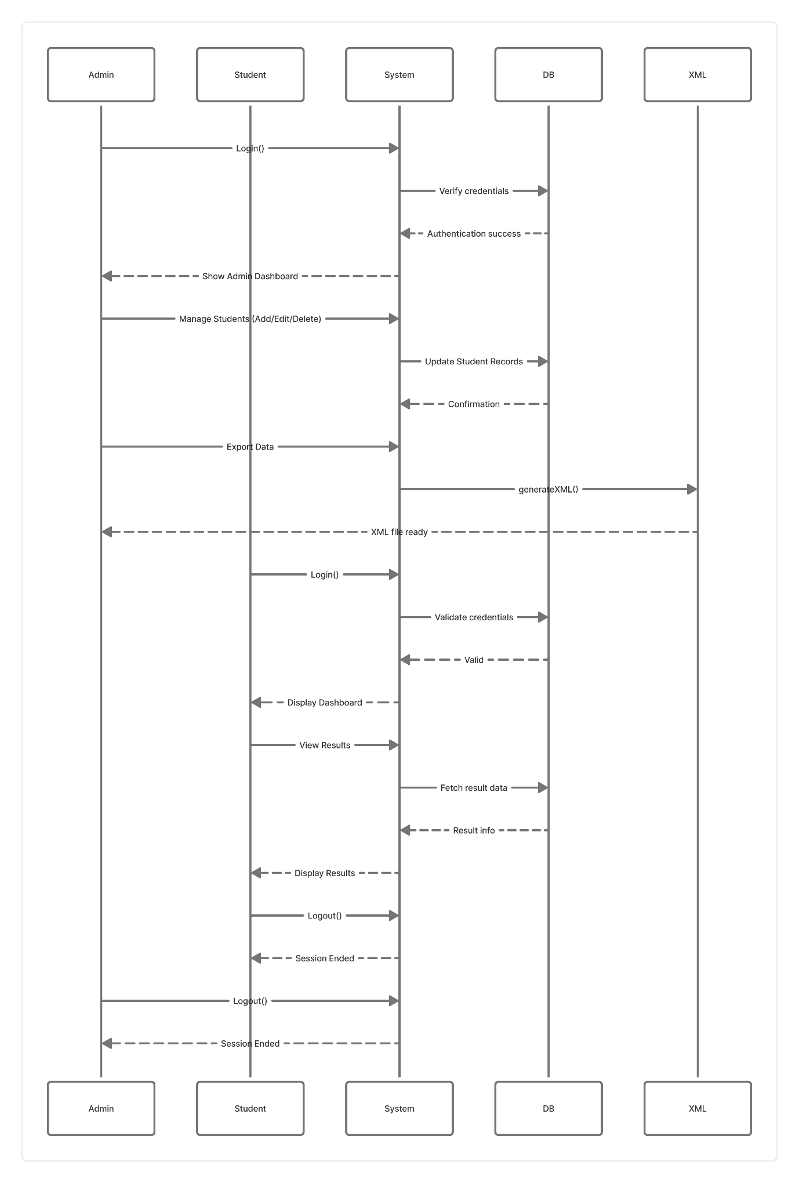
Figure B.6.2: Component Diagram
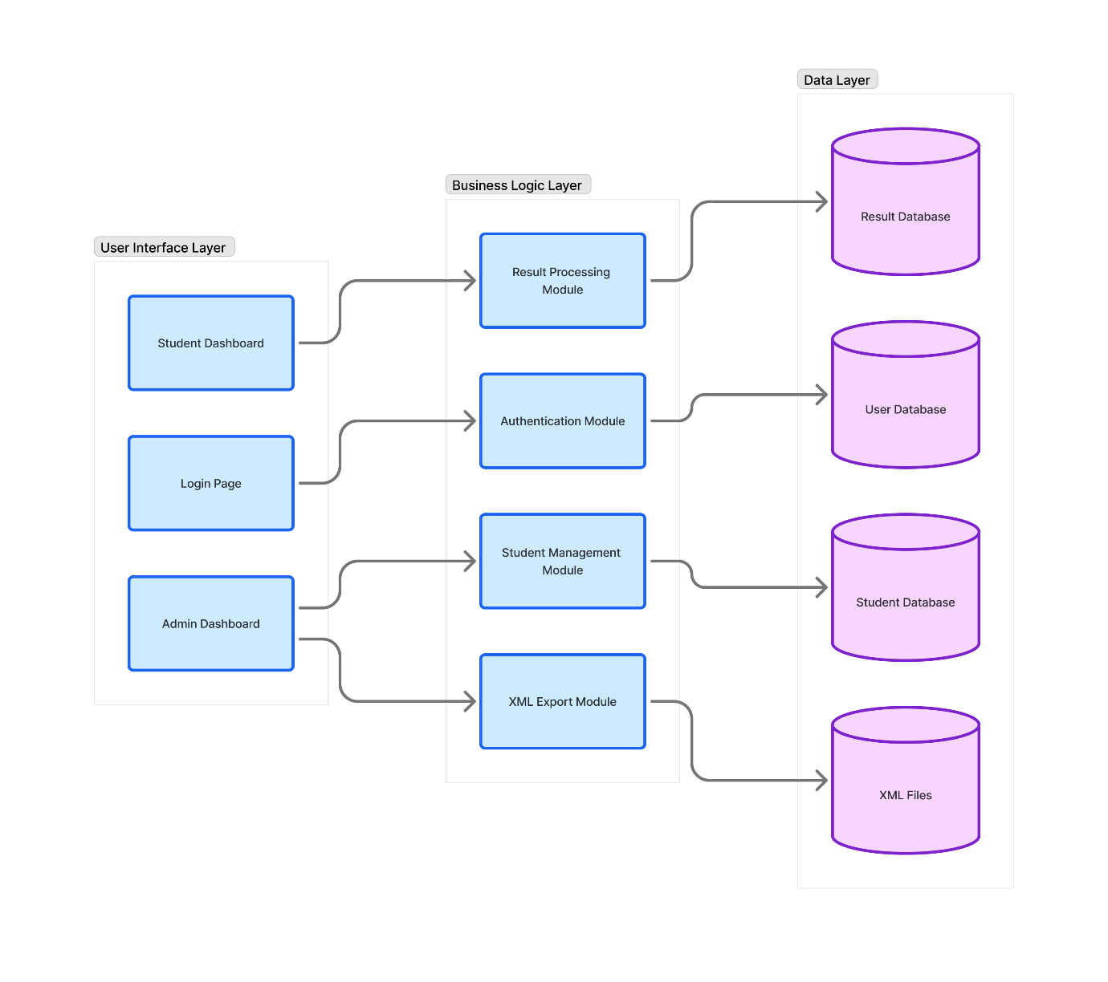
Figure B.6.2: Deployment Diagram
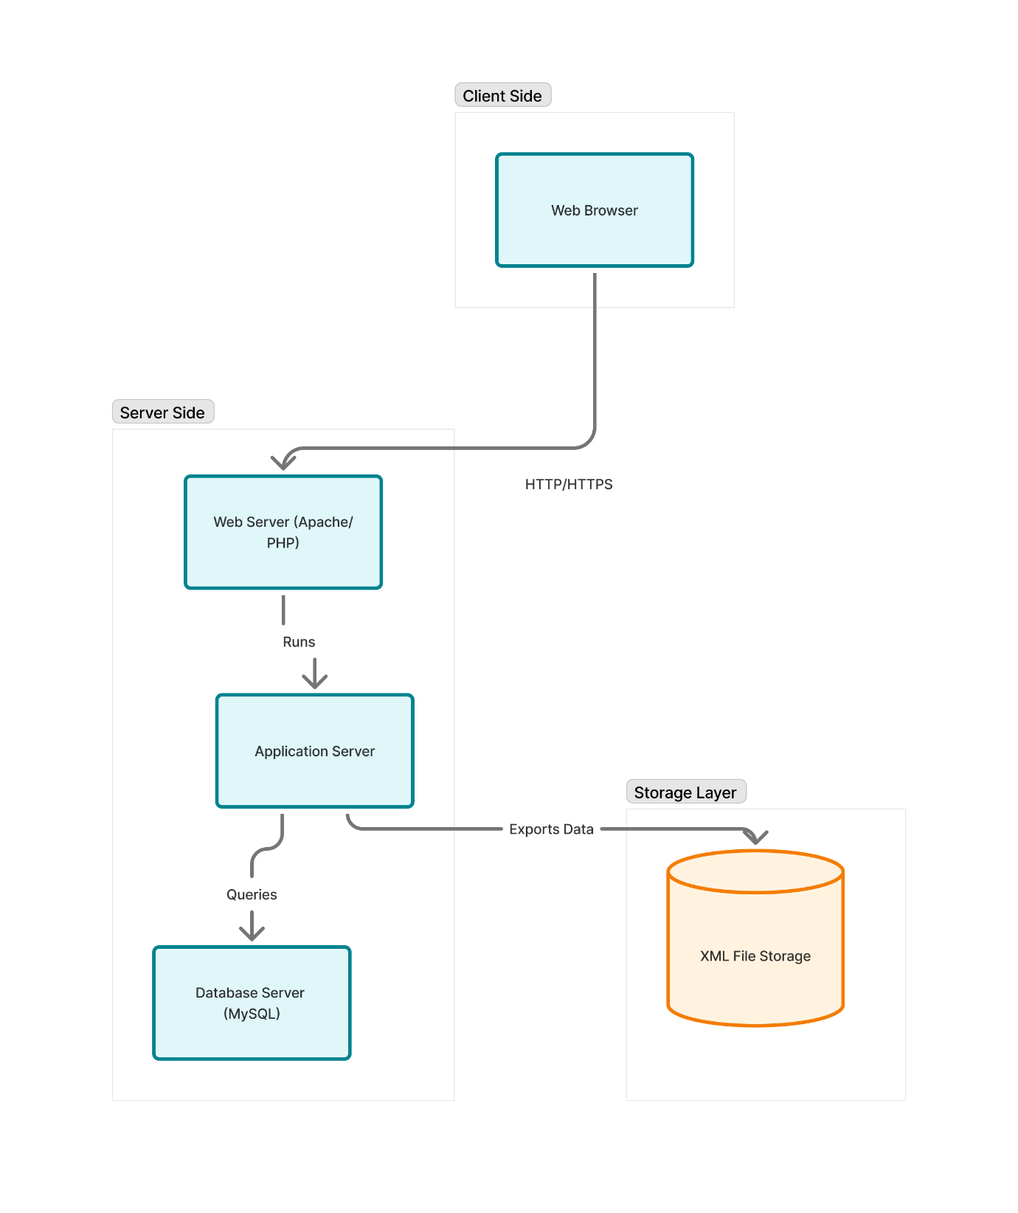

Appendix C – To Be Determined (TBD) List
- Final hosting server configuration.
- User interface color theme and branding.
- XML export file structure.
- Database normalization depth for new modules.
- Mobile application integration scope.

